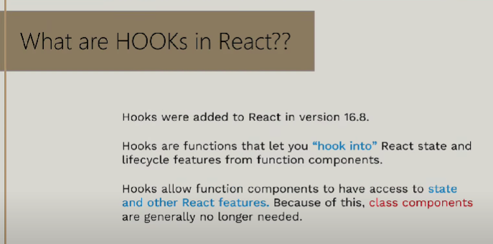

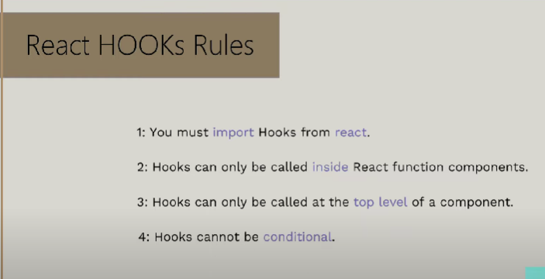

***useStateHook***

***It returns an array of two elements.***

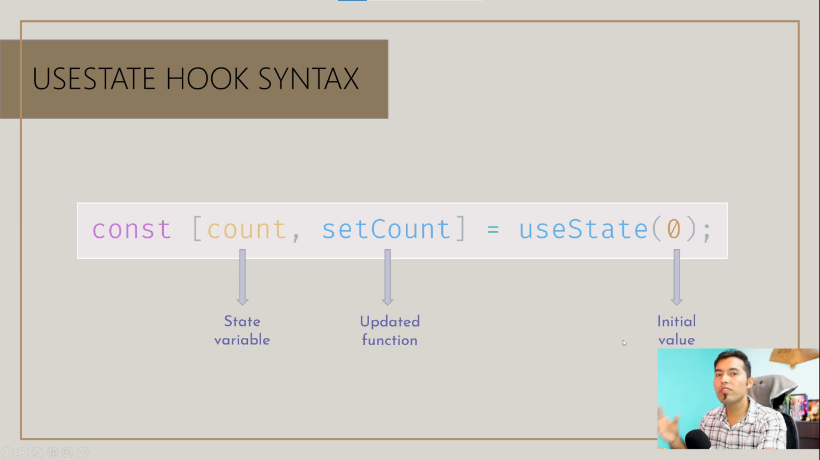

***We use this hook to change the state of our state variable. We also use it to store value just like in our signin, signup form, we have different fields and to store their value.***